1. ~~Table should not be expanded when page loads~~
2. ~~Submit button to be disabled and grayed out and it should not be clickable~~
3. ~~Add New Student Button should add new student with dummy values and dummy values should be dynamically added e.g for row 4 the values will be Student 4, Teacher 4 etc. and for row 5 the values will be Student 5, Teacher 5 etc.~~
4. ~~For newly added rows make sure existing CSS are applied too.~~
5. ~~After successful add of the record display the pop-up message as Record added successfully (any user-friendly message is also fine) and display error message in case add of record addition failed.~~

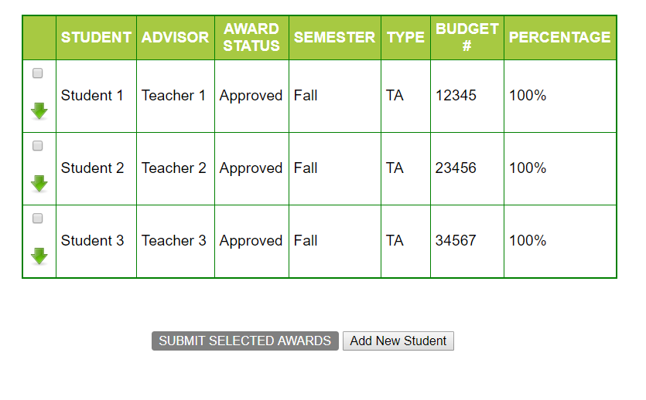

1. On selecting any of the check-boxes,  
   i~~] Background color to be changed for the particular row to “Yellow” and~~   
   ~~ii] Submit button to turn orange~~.   
   ~~iii]A delete button should get added dynamically in DELETE column and should delete the entire row when clicked. Also, pop-up message should be displayed by saying that Record deleted successfully.~~

~~iv) An Edit button should get added dynamically in EDIT COLUMN and should only display pop up box with message “Edit the details”. No need to display the field names~~

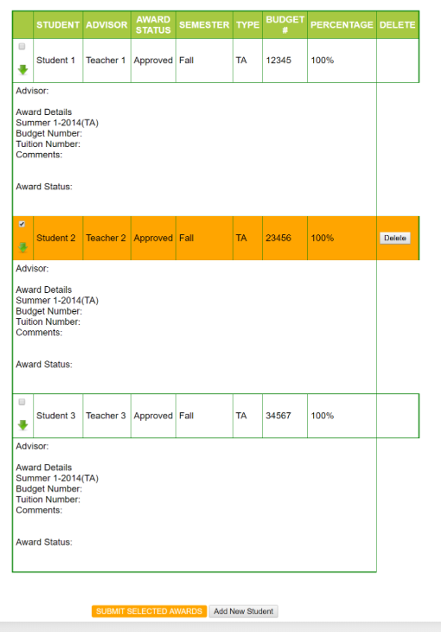

1. Deselecting the check box will
2. ~~make the row background color white again.~~
3. ~~Also, if none of the rows are selected, the Submit button should be Grayed out again(disabled). (i.e., if 1 or more of the check-boxes are selected, the Submit button will be enabled and background color will be yellow. If none are selected, it will be disabled and background set to Gray)~~
4. ~~DELETE button in those de-selected rows will be hidden~~
5. ~~EDIT button in those de-selected rows will be hidden~~

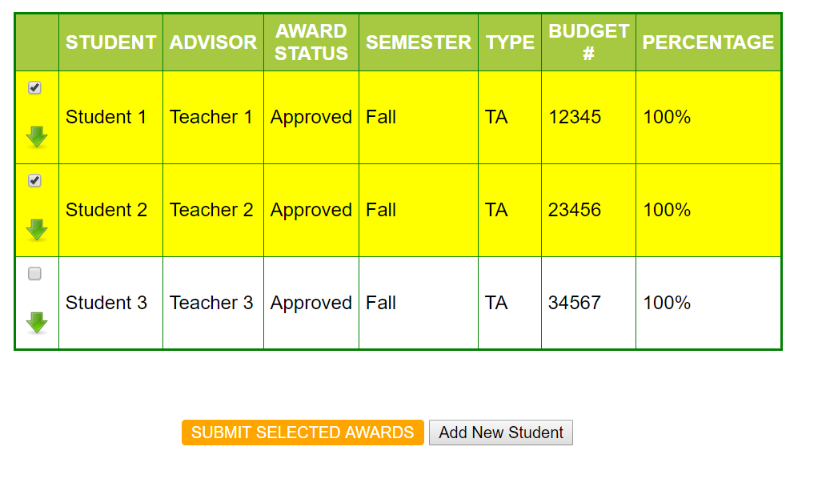

1. ~~Clicking on any of the green arrows will expand the particular row. Clicking it again will collapse it (i.e., toggle view on click)~~

